**Electronic supplementary information**

**RHENACARBORANE [1,1-(CO)2-1,1-I2-*isonido*-1,2,4-  
ReC2B8H10]–. SYNTHESIS, PROPERTIES, AND  
MOLECULAR STRUCTURE**

E. V. Balagurova,\**a* F. M. Dolgushin,*b* E. G. Kononova,*a*A. A. Kissel,*a* and S. M. Peregudova*a,c*

*a Nesmeyanov Institute of Organoelement Compounds, Russian Academy of Sciences,  
ul. Vavilova 28, str. 1, Moscow, 119334 Russia*

*b Kurnakov Institute of General and Inorganic Chemistry, Russian Academy of  
Sciences, Leninskii pr. 29, Moscow, 119991 Russia*

*c Enikolopov Institute of Synthetic Polymeric Materials, Russian Academy of Sciences,  
ul. Profsoyuznaya 70, Moscow, 117393 Russia*

Experimental section

General remarks

Carborane *nido*-5,6-C2B8H12 was prepared by the published method [S1]. CH2Cl2 was distilled over CaH2. Synthesis and isolation of complex **2** was carried out in the air. Silica gel from Acros (0.035–0.070 mm 60 Å) was used for column chromatography. The NMR spectra were recorded on a Varian Inova 400 MHz spectrometer. The IR spectra were obtained on a Bruker Tensor 37 FT-IR spectrometer in KBr pellets. The UV-Vis spectra were recorded on a Carl Zeiss Specord M 40 spectrophotometer for solutions of **1** and **2** in CH2Cl2.

**Syntheses of complex** **2**

A solution of I2 (28 mg, 0.11 mmol) in 5 mL of CH2Cl2 was added dropwise to a solution of complex **1** (65 mg, 0.11 mmol) in 10 mL of CH2Cl2 at –50 °C. The reaction mixture was brought to room temperature and stirred for 1 h. The solvent was removed under vacuum. The residue obtained was washed with hexane until hexane stopped to be colored. The crystallization was carried out from a CH2Cl2–hexane mixture. Complex **2** was obtained as orange crystals. Yield: 60 mg (66%). 1H NMR (400 MHz, CD2Cl2, 20 °C): *δ* 19.38 (s, 1H, tmndH+), 8.06–7.71 (m, 6H, tmndH+), 7.12 (sbr, 1H, CH-carb), 3.81 (br. s, 1H, CH-carb), 3.18 (s, 12H, tmndH+) ppm. 11B NMR (128 MHz, CD2Cl2, 20 °C): *δ* 50.8 (d, 1B, *J* = 171 Hz), 18.5 (d, 1B, *J* = 156 Hz), 3.5 (d, 1B, *J* = 155 Hz), –8.6 (d, 1B, *J* = 148 Hz), –16.3 (d, 1B, *J* = 178 Hz), –22.1 (d, 1B, *J =* 154 Hz), –25.0 (d, 1B, *J =* 158 Hz), –30.8 (d, 1B, *J =* 147 Hz) ppm. 13C NMR (100 MHz, CD2Cl2, 20 °C): *δ* 197.63 (CO), 194.52 (CO), 143.15 (tmndH+ (naphth.)), 135.57 (tmndH+ (naphth.)), 130.01 (tmndH+ (naphth.)), 127.33 (tmndH+ (naphth.)), 121.27 (tmndH+ (naphth.)), 118.49 (tmndH+ (naphth.)), 63.94 (CH-carb.), 46.78 (CH3 tmndH+) ppm. IR (nujol, *ν*/cm–1): 2546 (BH), 2036, 1989 (CO). Anal. Calcd. for C18H29B8O2N2I2Re: C, 25.98; H, 3.49. Found: C, 25.61; H, 3.20%.

**X-ray diffraction analysis of 2**

Crystals (C18H29B8I2N2O2Re, *M* = 831.91) are triclinic, space group *P*-1, at 296K *a* = 7.9715(3), *b* = 12.8346(5), *c* = 14.4779(5) Å, *α* = 97.2701(13), *β*= 97.1120(12), *γ* = 103.4553(13)°, *V* = 1410.86(9) Å3, *Z* = 2, *d*calc. = 1.958 g/cm3, *μ* = 65.13 cm-1. The data collection was carried out with a Bruker SMART APEX II diffractometer, *λ*(MoKα) = 0.71073 Å, *ω*-scan technique, *T* = 296(2) K, 6100 independent reflections (*R*int = 0.0376) with *2θmax =* 54.0° collected and used in refinement. The structure was solved by direct methods and refined by the full matrix least-squares technique against *F*2 with the anisotropic thermal parameters for all non-hydrogen atoms. Semi-empirical adsorption correction (*T*min/max = 0.217/0.562) was applied using the SADABS program [S2]. At the final stage, the structure was refined as a two-component twin (BASF is 0.059(1)). Hydrogen atoms of the carborane ligand and NH group of the cation were located in the difference Fourier maps and freely refined without constraints. The other hydrogen atoms were placed in calculated positions and refined using a riding model with *Uiso*(H) = 1.5*Ueq*(C) for hydrogen atoms of methyl groups and *Uiso*(H) = 1.2*Ueq*(C) for aromatic hydrogen atoms. The refinement converged to *wR2* = 0.0807 and GOF = 1.163 for all independent reflections (*R1* = 0.0329 was calculated against *F* for 5872 observed reflections with I > 2σ(I)). All calculations were performed using the SHELXL program package [S3]. CCDC deposition number 2388455 contains the supplementary crystallographic data for this paper.

**Electrochemical measurements**

Cyclic voltammetry measurements were performed on an IPC-Pro M potentiostat for *ca.* 10–3 M solutions of compounds **1** and **2** in rigorously dried CH2Cl2 in a standard three-electrode cell equipped with a glassy carbon working electrode (*S* = 2 mm2), platinum plate as the counter electrode, and SCE (saturated calomel electrode) as the reference electrode. The scan rate was 100 mV·s–1. A solution containing 0.2 M Bu4NPF6 was used as the supporting electrolyte, and a ferrocene–ferrocenium pair (*E*0 = 0.47 V) was applied as the internal standard.

**NMR spectra**

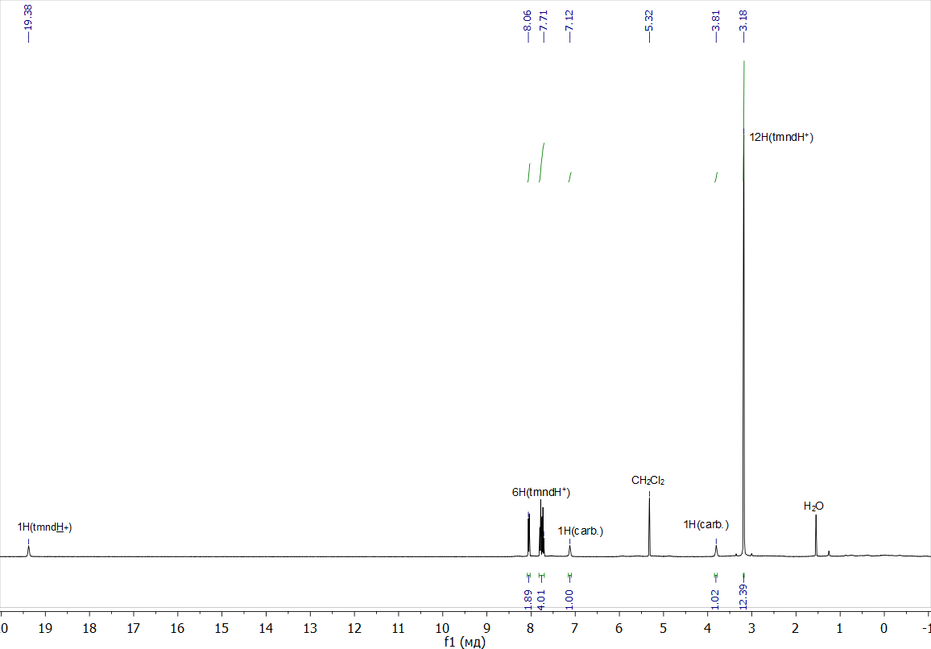

1H NMR spectrum of compound **2**

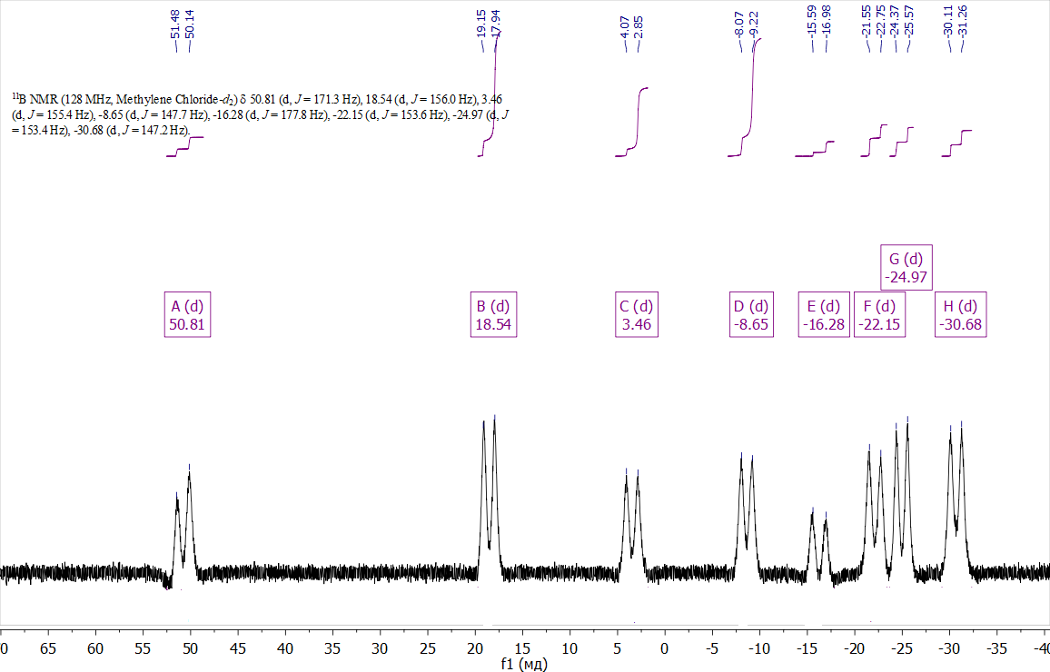

11B NMR spectrum of compound **2**

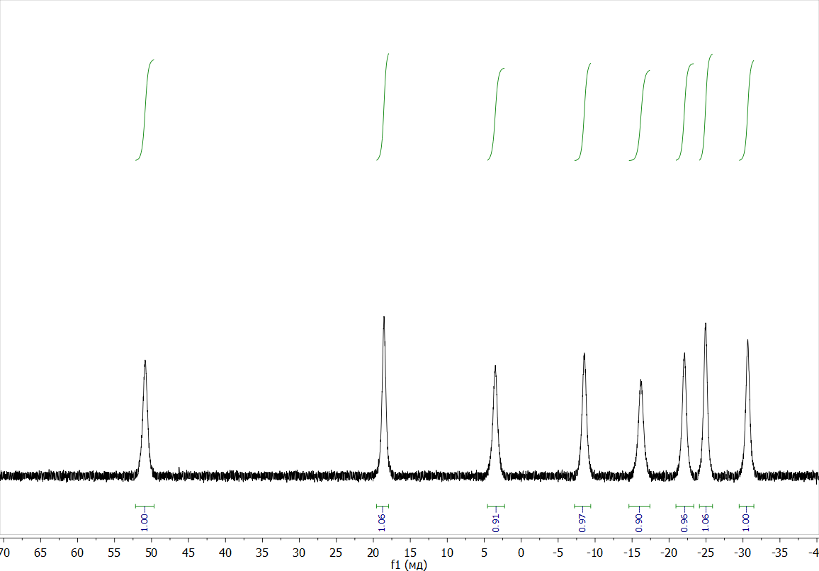

11B{1H} NMR spectrum of compound **2**

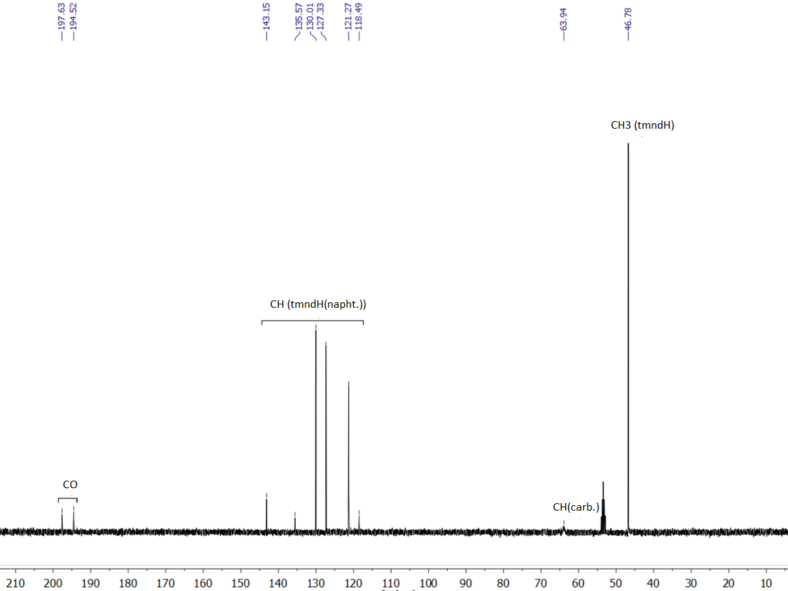

13C NMR spectrum of compound **2**

**Cyclic voltammetry**

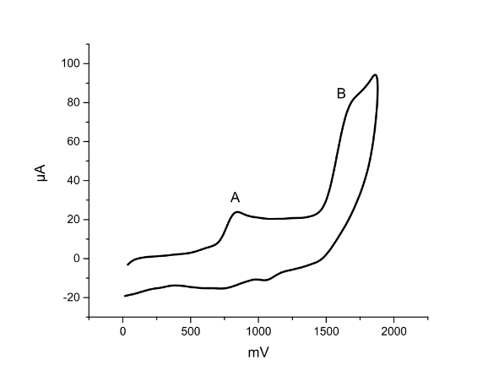

Cyclic voltammetry of the oxidation of complex **1** in CH2Cl2 *v* = 100 mV/s

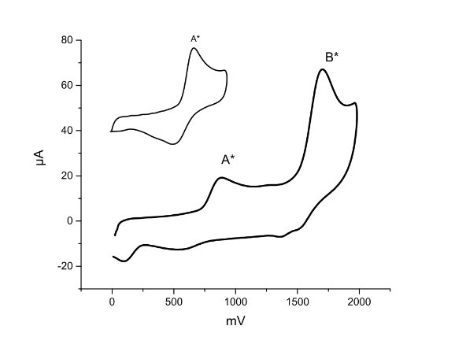

Cyclic voltammetry of the oxidation of complex **2** in CH2Cl2 *v* = 100 mV/s

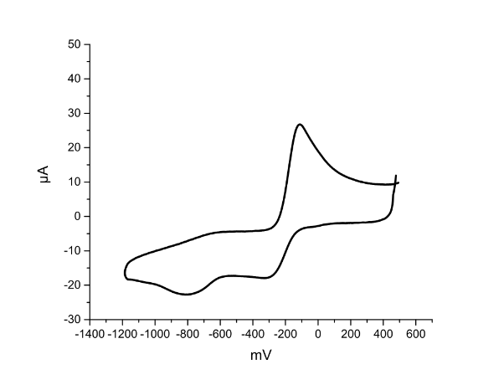

Cyclic voltametry of the reduction of complex **2** in CH2Cl2 *v* = 100 mV/s

**UV-Vis and IR spectra of complex 1 and 2**

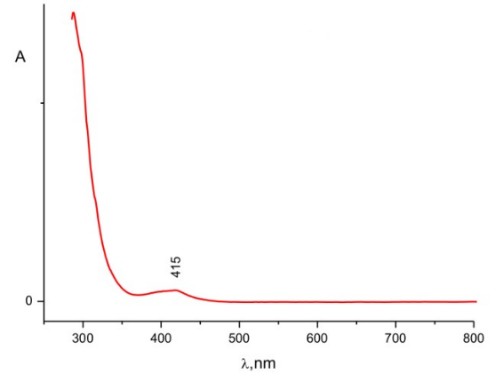

UV-Vis spectra of complex **1**

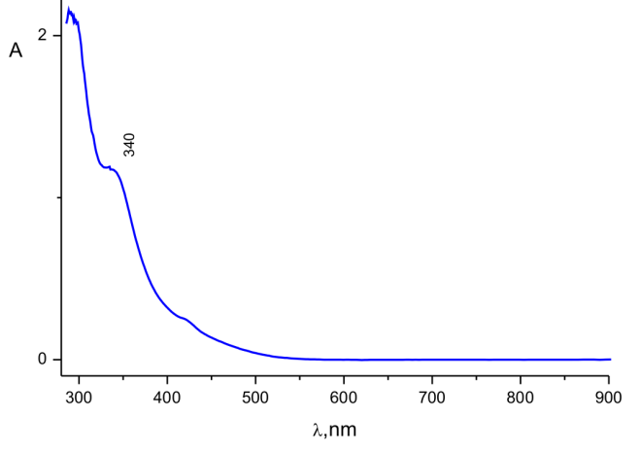

UV-Vis spectra of complex **2**

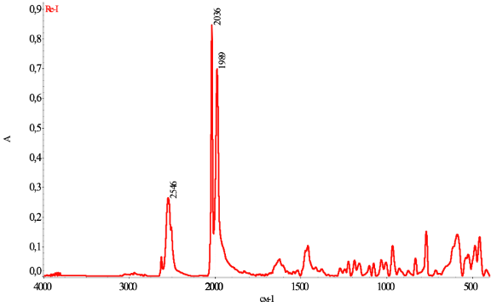

IR spectrum of complex **2**

**References**

S1. B. Štíbr, J. Holub, T. Jelínek, B. Grüner, J. Fusek, Z. Plzák, F. Teixidor, C. Viñas, J. D. Kennedy, *Collect. Czech. Chem. Commun.*, **1997**, *62*, 1229–1238. DOI: 10.1135/cccc19971229

S2. SADABS, Version 2016/5, Bruker AXS Inc., Madison, Wisconsin, USA.

S3. G.M. Sheldrick, *Acta Cryst*., *Sect. C: Struct. Chem.*, **2015**, *71*, 3–8. DOI: 10.1107/S2053229614024218